SEC Form 3
FORM 3 | UNITED STATES SECURITIES AND EXCHANGE COMMISSION
 | Washington, D.C. 20549
 | Washington, D.C. 20549 |  | OMB APPROVAL
 | INITIAL STATEMENT OF BENEFICIAL OWNERSHIP OF SECURITIES
 | INITIAL STATEMENT OF BENEFICIAL OWNERSHIP OF SECURITIES |  | OMB Number: | 3235-0104
 |  |  | Estimated average burden
 | Filed pursuant to Section 16(a) of the Securities Exchange Act of 1934 |  | hours per response: | 0.5
or Section 30(h) of the Investment Company Act of 1940
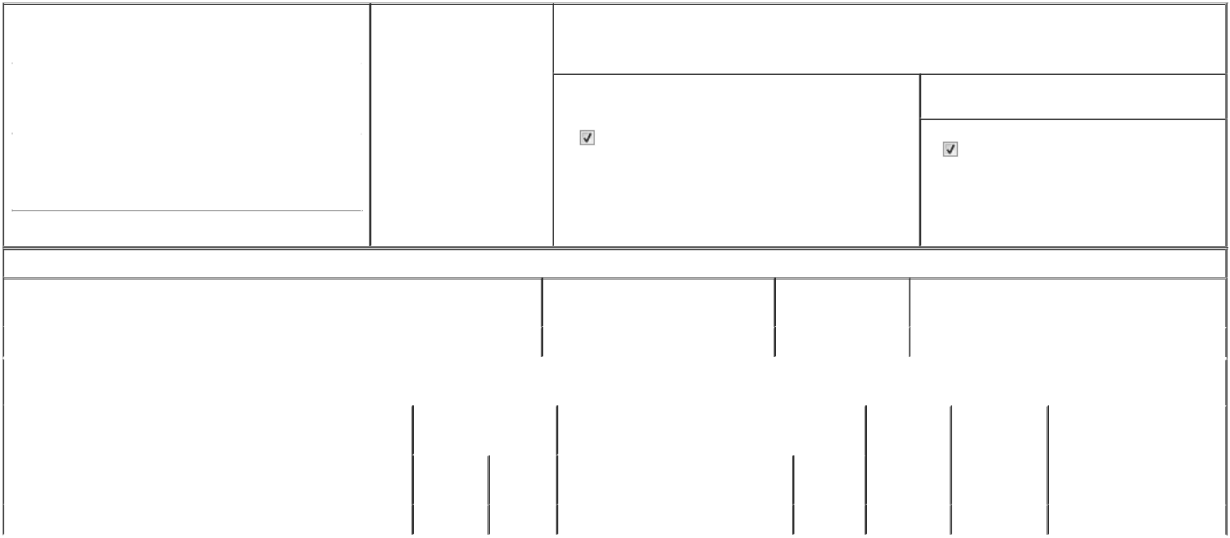

1. Name and Address of Reporting Person* |  |  |  | 2. Date of Event Requiring
 |  | Kerr Kimberly |  | Statement (Month/Day/Year)
 |  | Kerr Kimberly |  | 06/22/2026

3. Issuer Name and Ticker or Trading Symbol

Anterix Inc. [ ATEX ]

 | (Last) | (First) | (Middle)
 | 3 GARRET MOUNTAIN PLAZA, SUITE 401
(Street)
 | WOODLAND | NJ | 07424
 | PARK | NJ | 07424

- Relationship of Reporting Person(s) to Issuer (Check all applicable)
Director | 10% Owner
Officer (give title | Other (specify below)
below) | Other (specify below)

Chief Revenue Officer

- If Amendment, Date of Original Filed (Month/Day/Year)

- Individual or Joint/Group Filing (Check Applicable Line)

Form filed by One Reporting Person

Form filed by More than One Reporting Person

(City) (State) (Zip)

Table I - Non-Derivative Securities Beneficially Owned

1. Title of Security (Instr. 4) | 2. Amount of Securities Beneficially | 3. Ownership Form: | 4. Nature of Indirect Beneficial Ownership (Instr. 5)
 | Owned (Instr. 4) | Direct (D) or Indirect
 |  | (I) (Instr. 5)

 | Common Stock |  |  |  | 3,363⁽¹⁾ | D
 |  |  | Table II - Derivative Securities Beneficially Owned
 |  | (e.g., puts, calls, warrants, options, convertible securities)
 | 1. Title of Derivative Security (Instr. 4) |  | 2. Date Exercisable and |  | 3. Title and Amount of Securities Underlying |  | 4. | 5. Ownership | 6. Nature of Indirect Beneficial
 |  |  | Expiration Date |  | Derivative Security (Instr. 4) |  | Conversion | Form: Direct | Ownership (Instr. 5)
 |  |  | (Month/Day/Year) |  |  |  | or Exercise | (D) or Indirect
 |  |  |  |  |  |  | Price of | (I) (Instr. 5)
 |  |  |  |  |  | Amount or | Price of | (I) (Instr. 5)
 |  |  |  |  |  | Amount or | Derivative
 |  |  | Date | Expiration | Title | Number of | Security
 |  |  | Exercisable | Date | Title | Shares
 | Stock Option (Right to Buy) | (2) |  | 06/02/2036 | Common Stock | 15,913 | 66.9 | D
 | Explanation of Responses:

- Represents the issuance of restricted stock units ("RSUs"). Each RSU represents a contingent right to receive one share of Issuer's Common Stock. The RSUs vest over three years, with 1/3 vesting on June 2, 2027, and 1/12 vesting quarterly thereafter on August 10, November 10, February 10, and May 20 of each year through May 20, 2029.

- The option shares vest and become exercisable over three years, with 1/3 vesting on June 2, 2027, and 1/12 vesting quarterly thereafter on August 10, November 10, February 10, and May 20 of each year through May 20, 2029.

Remarks:

 | /s/ Gena L. Ashe, Attorney-in-Fact |  |  | 07/01/2026
 | ** Signature of Reporting Person |  | Date
Reminder: Report on a separate line for each class of securities beneficially owned directly or indirectly.
* If the form is filed by more than one reporting person, see Instruction 5 (b)(v).
** Intentional misstatements or omissions of facts constitute Federal Criminal Violations See 18 U.S.C. 1001 and 15 U.S.C. 78ff(a).
Note: File three copies of this Form, one of which must be manually signed. If space is insufficient, see Instruction 6 for procedure.
Persons who respond to the collection of information contained in this form are not required to respond unless the form displays a currently valid OMB Number.



